Airfoil Selection for Two RC Aircraft: Heavy-Lift (A) and Aerobatic (B)
Technical report. All numbers marked ~ are approximate, typical low-Reynolds-number values from published/XFOIL-style data and must be replaced with your own XFLR5 results before submission (see Section 8).

1. Purpose and Method
An airfoil is the 2D cross-section of the wing. It sets the potential of the wing (how much lift per unit area, how much drag, how it stalls), but how the whole aircraft flies also depends on wing loading, tail, controls, structure and power. This report picks one airfoil for each mission by (1) turning the mission into airfoil requirements, (2) shortlisting candidates, (3) comparing them at one Reynolds number, and (4) choosing the one whose weaknesses are cheapest to fix at the aircraft level.
Assumptions (state these in your own submission):
- Sea-level air: density 1.225 kg/m³, kinematic viscosity 1.46×10⁻⁵ m²/s.
- Electric-powered, conventional tail-aft layout, no flaps unless stated.
- Re = V·c/ν. For both aircraft the Reynolds number comes out near 2.5×10⁵, so all comparisons use Re = 250,000 (Ncrit = 9, free transition). At this Re, laminar separation bubbles matter, so low-Re data (UIUC, Selig) is more trustworthy than classic NACA data from Re of millions.
- 3D effects: finite-wing CLmax is taken as roughly 85–90% of the 2D value.
 | Aircraft A (payload) | Aircraft B (aerobatic)
Span / mean chord | 2.0 m / 0.275 m | 1.2 m / 0.25 m
Wing area S | 0.55 m² | 0.30 m²
Aspect ratio | ~7.3 | ~4.8
Max takeoff mass | 6 kg (incl. 2 kg payload) | 1.4 kg
Wing loading | ~10.9 kg/m² | ~4.7 kg/m²
Design speed | 14 m/s cruise | 18–20 m/s
Re at design speed | ~2.6×10⁵ | ~3.1×10⁵

2. What Each Mission Demands of the Airfoil
Aircraft A (maximum payload, stable). Lift must equal weight: W = ½ρV²·S·CL. To carry more weight without a bigger wing or a dangerous takeoff speed, the airfoil must give high CLmax, and ideally good L/D at high CL (long endurance, low power for climb). Stability requirements push the other way: strong camber produces a large nose-down pitching moment (Cm0), which the tail must balance with a download, costing trim drag and requiring a longer tail arm. We also want a gradual, forgiving stall because the aircraft will be heavily loaded, and enough thickness for a deep spar to carry bending loads.
Aircraft B (maneuverability). Turn rate and loop capability depend on the load factor n = L/W the wing can generate at speed, and on how well the aircraft behaves when pitched hard, inverted, or knife-edge. So we want: symmetric or near-symmetric section (same behavior upright and inverted, Cm0 ≈ 0 so trim does not change with attitude), a predictable stall with a gentle lift-curve peak, low drag so energy is kept through loops, and moderate thickness to keep the structure light and stiff.

3. Shortlisted Airfoils

Aircraft A candidates
- Clark Y — classic flat-bottom, ~11.7% thick, ~3.4% camber. Docile, easy to build, very forgiving. Modest CLmax.
- NACA 4412 — ~12% thick, 4% camber. Well-documented baseline, moderate lift.
- Eppler E423 — ~12.5% thick, ~9–10% camber. A high-lift low-Re section from the Eppler family. Very high CLmax with high L/D at high CL.
- Selig S1223 — ~12% thick, ~8.7% camber, strongly aft-loaded. Among the highest CLmax values of any low-Re section, but with a very large nose-down moment.

Aircraft B candidates
- NACA 0009 — 9% thick symmetric. Low drag, but thin.
- NACA 0012 — 12% thick symmetric. The standard aerobatic baseline.
- NACA 0015 — 15% thick symmetric. Deep and strong, softer stall, more drag.
- NACA 2412 (comparison only) — 12% thick, 2% camber. Shows what a mild-camber compromise gives.

4. Comparison Table (Re ≈ 250,000, approximate values)
Airfoil | Max thickness | Max camber | CLmax (2D) | Cd at CL≈0.5 | (L/D)max | Cm0 | Stall character
Clark Y | 11.7% | 3.4% | ~1.3–1.4 | ~0.014 | ~45–55 | ~ −0.08 | Gentle, trailing-edge led
NACA 4412 | 12% | 4% | ~1.4 | ~0.014 | ~45–55 | ~ −0.10 | Gentle
Eppler E423 | 12.5% | ~9–10% | ~1.9–2.0 | ~0.018 | ~65–80 | ~ −0.20 to −0.25 | Progressive, but high AoA before stall
Selig S1223 | ~12% | ~8.7% | ~2.1–2.2 | ~0.022 | ~60–70 | ~ −0.27 | Gradual but high drag, heavy nose-down moment
NACA 0009 | 9% | 0% | ~0.9–1.0 | ~0.012 | ~30–40 | 0 | Sharper, leading-edge type
NACA 0012 | 12% | 0% | ~1.0–1.1 | ~0.013 | ~35–45 | 0 | Moderate, predictable, symmetric
NACA 0015 | 15% | 0% | ~1.1–1.2 | ~0.015 | ~30–35 | 0 | Soft, rounded peak
NACA 2412 | 12% | 2% | ~1.2–1.3 | ~0.013 | ~40–50 | ~ −0.05 | Gentle
Note that the NACA 00xx sections have zero lift at zero angle of attack, so the "CL at α = 0" is 0, whereas cambered sections produce positive lift there (about 0.1 CL per 1% camber is a rough rule of thumb).
Sources for this kind of data: UIUC Low-Speed Airfoil Tests, Airfoil Tools, and XFOIL/XFLR5 runs (see references and the citation caution at the end).

5. Selections and Justification

Aircraft A: Eppler E423
Why it wins on the mission. Payload capacity is limited by stall speed and wing area. Using the sample design (6 kg, S = 0.55 m²), W = 58.9 N. Using a 3D CLmax of about 1.7 for E423 (2D ~1.95 × ~0.87) gives
Vs = √(2W / ρ·S·CL) = √(117.7 / (1.225 × 0.55 × 1.7)) ≈ 10.1 m/s.
With Clark Y (3D CLmax ≈ 1.2) the same aircraft stalls at ≈ 12.1 m/s, or, to keep Vs at 10.1 m/s, it would need about 40% more wing area (1.7/1.2). More area means more weight, more drag and a bigger structure. So E423's high CLmax converts directly into either more payload at the same size or a safer, shorter takeoff.
Why not S1223. It has even more lift, but its Cm0 of about −0.27 is the largest of the group. Balancing that needs a big tail download (which subtracts from useful lift), a longer tail arm, and a very careful CG. Its drag at moderate CL is also higher. For a student build where "stable flight" is an explicit requirement, the extra ~0.1–0.2 of CL is not worth the trim penalty. It is the right choice for a competition team with a tail designed around it.
Why not Clark Y/4412. They are safe and easy, but they leave too much payload on the table for a "maximum payload" brief.
Known trade-offs of E423 (and how to cover them): nose-down moment (use tail volume coefficient ~0.5–0.6 horizontal, CG ahead of the neutral point with 8–15% MAC static margin); higher drag at high speed (acceptable, since the mission is slow and heavy); thin trailing edge (use a stiff built-up or foam-core wing and a full-depth spar). Add a few degrees of washout to protect aileron effectiveness near the stall.
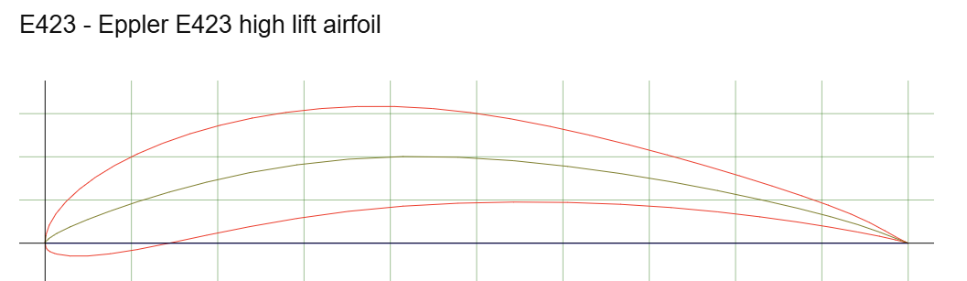
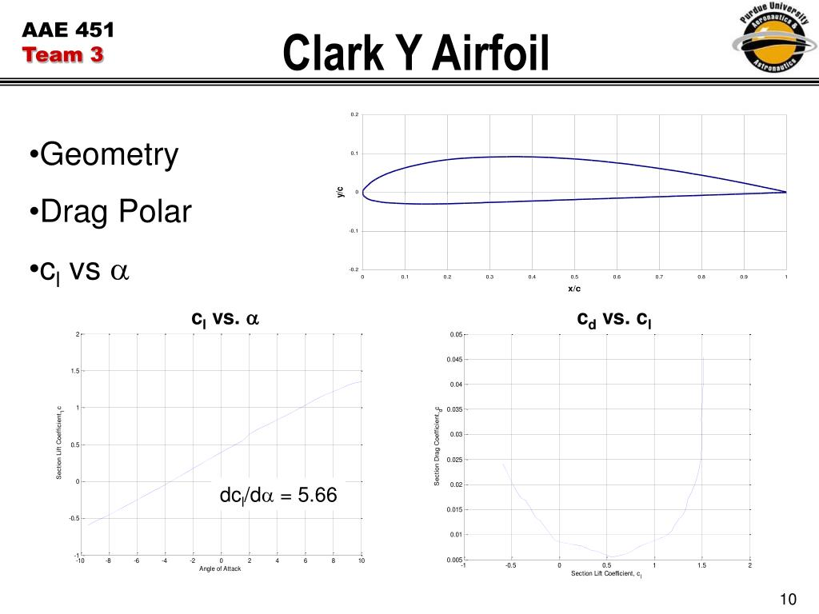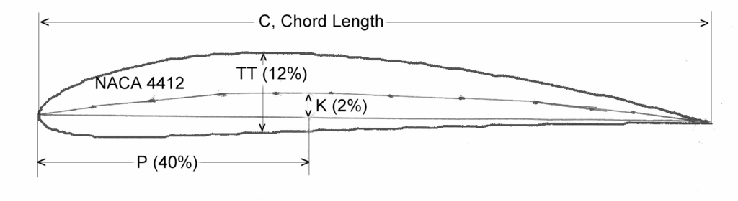
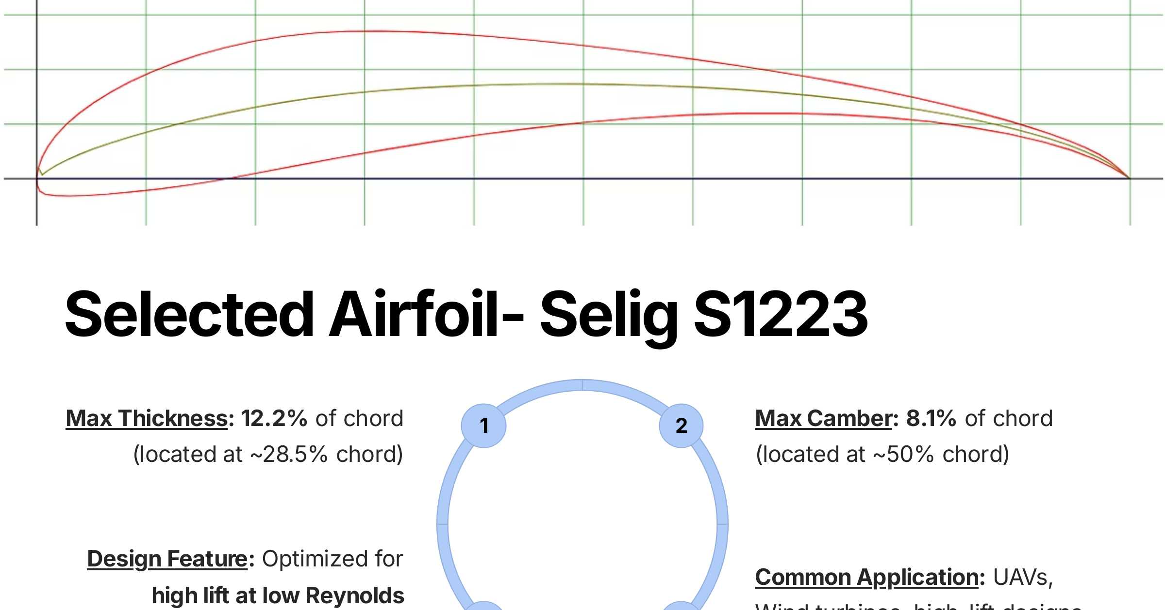

Aircraft B: NACA 0012
Why it wins on the mission. Because it is symmetric, the aircraft flies identically upright or inverted, the pitch trim does not shift during rolls, and the pitching moment about the quarter chord is essentially zero, so the tail can be small and the elevator light. Its CLmax of ~1.0 is low compared to A, but that does not matter for B since the aircraft is light.
Using the sample design (1.4 kg, S = 0.30 m², W = 13.7 N) at 20 m/s with 3D CLmax ≈ 0.9:
maximum lift= ½ρV²S·CL = 0.5 × 1.225 × 400 × 0.30 × 0.9 ≈ 66 N, so maximum load factor ≈ 4.8 (aerodynamic limit).
Turn radius at that load factor: R = V² / (g·√(n²−1)) = 400 / (9.81 × 4.7) ≈ 8.7 m. That is tight enough for loops and snap manoeuvres. The low wing loading (4.7 kg/m²) is what delivers that, not the airfoil alone.
Why not 0009. Thinner wins on drag, but a 9% section on a 0.25 m chord leaves a very shallow spar (about 22 mm), and its stall is sharper because the small leading-edge radius leads to leading-edge separation.
Why not 0015. A deeper section is stronger and has a softer stall, but about 15–20% more drag, which bleeds energy in vertical manoeuvres.
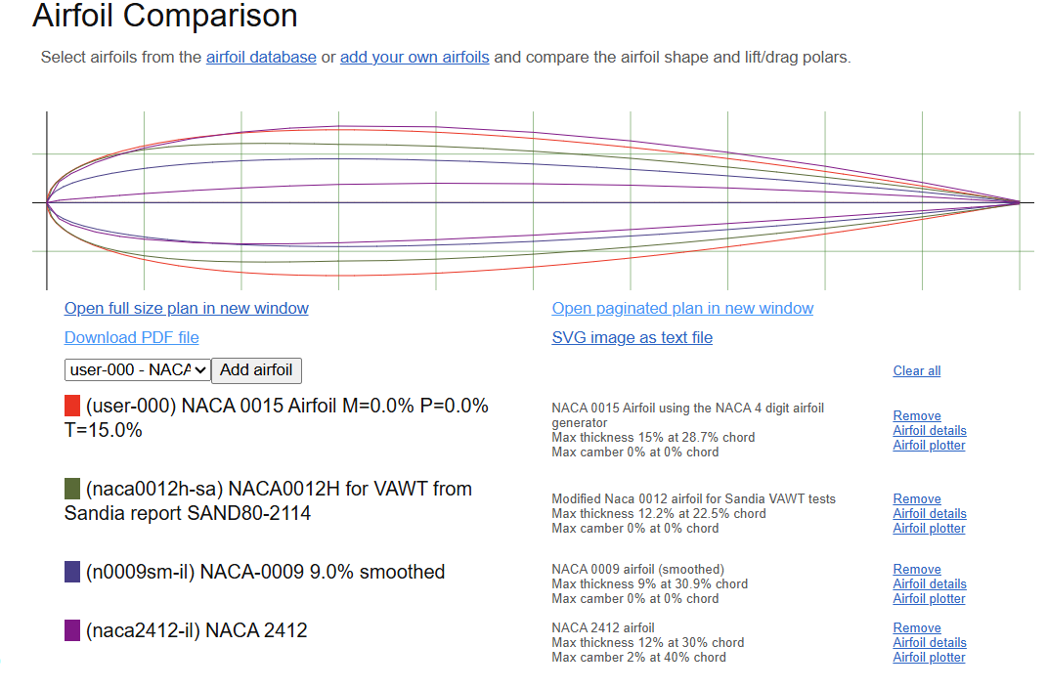

. How Airfoil Geometry Affects Performance
- Camber shifts the whole lift curve upward: α for zero lift moves to a negative angle (about −1° per 1% camber, roughly), which raises CL at a given angle and raises CLmax. The cost is a more nose-down Cm0 and more drag at low CL. Camber is why A can carry weight, and its absence is why B can fly inverted.
- Thickness raises CLmax up to about 12–15% by allowing a rounder nose and a more gradual pressure recovery. Beyond that, drag rises (more form drag, earlier separation) and Re sensitivity grows. Thickness also gives structural depth: bending stiffness of a spar grows roughly with the cube of its depth.
- Leading-edge radius controls stall type. A small radius gives abrupt leading-edge separation (sharp stall). A larger radius lets the flow turn the corner to a higher angle and gives a trailing-edge-led, gradual stall.
- Position of maximum camber and thickness. Aft camber increases lift and the nose-down moment (E423, S1223). Forward thickness (as in the 63-series laminar sections) lowers drag at a design CL but narrows the low-drag range, which is a poor match at low Re.
- Trailing-edge angle affects pressure recovery and how thin the TE gets. Thin TEs are fragile on small models.
- Reynolds number. At Re of 2–3×10⁵ laminar separation bubbles appear on the upper surface and can cause a sudden drag rise or an early stall. Selig/Eppler sections are designed to control them. Classic NACA data at Re of millions overstates performance.

7. Can One Airfoil Do Both Jobs?
Technically yes, with a compromise, but both aircraft would be worse.
- Using E423 on B: a ~10% camber airfoil flown inverted performs poorly (the camber is now working against you), Cm0 ≈ −0.22 would shift pitch trim dramatically between upright and inverted, and the drag in a vertical dive is high. B would be unpleasantly trim-sensitive.
- Using NACA 0012 on A: at the same 6 kg load and S, Vs ≈ √(117.7 / (1.225 × 0.55 × 0.9)) ≈ 13.9 m/s, so it would either need around 90% more wing area or a much higher takeoff speed. Payload would drop heavily.
- A middle option (NACA 2412 ) gives usable stability and moderate lift, and modest aerobatics. This is common for trainers but can't be best at either end: a semi-symmetric section is ~25–35% below E423 in CLmax and not truly symmetric for inverted flight.
The fundamental trade-off is CLmax and L/D at high CL (camber) vs. symmetry and trim independence (zero camber). Variable geometry (flaps/flaperons) can recover part of the gap, effectively adding camber on demand, but adds weight and complexity.

8. Airfoil vs. Whole-Aircraft Factors
Factor | Airfoil-level | Aircraft-level
Max lift | CLmax, α_stall | Wing area, wing loading (W/S), AR, taper, washout, flaps
Drag | Cd0, shape, Re behavior | Total wetted area, fuselage/gear interference, induced drag (AR, e)
Stability | Cm0, Cm_α about the quarter chord | CG position, static margin, tail volume, tail arm, wing/tail incidence
Maneuverability | Symmetric behavior, stall type | Wing loading, thrust-to-weight, aileron/elevator size and throw, control-surface hinge gaps, inertia (roll/pitch)
Structure | Thickness (spar depth) | Spar design, materials, fuselage stiffness, flutter margins
Propulsion | N/A | Motor/prop thrust, power loading, battery
Example: roll rate on B is dominated by aileron span/chord, deflection and wing roll inertia, with the airfoil contributing only through lift-curve slope and stall behavior. Likewise, A's payload depends at least as much on thrust (takeoff distance), battery and structure as on E423's CLmax.

9. Conclusions
- Aircraft A: Eppler E423, chosen for ~40% more usable CLmax than Clark Y with manageable pitching moment and good L/D at high CL.
- Aircraft B: NACA 0012, chosen for symmetry, predictable stall, adequate thickness and low drag.
- One airfoil cannot serve both missions without a performance compromise. Camber and symmetry are in direct conflict.
- The airfoil defines potential. Wing loading, tail, controls, structure and thrust decide whether it is realised.

References
- Abbott, I. H. and von Doenhoff, A. E., Theory of Wing Sections, Dover, 1959.
- Selig, M. S. et al., Summary of Low-Speed Airfoil Data (Vols. 1–5), SoarTech Publications, and the UIUC Low-Speed Airfoil Tests website.
- Drela, M., "XFOIL: An Analysis and Design System for Low Reynolds Number Airfoils," in Low Reynolds Number Aerodynamics, Springer, 1989.
- Raymer, D. P., Aircraft Design: A Conceptual Approach, AIAA.
- Anderson, J. D., Fundamentals of Aerodynamics, McGraw-Hill.
- airfoiltools.com (airfoil coordinates, diagrams and polars).
- XFLR5 for plots and graphs(attached along with this file)
- gamma.app for diagrams

